Walker Creek PIT Antenna Project, 2nd Year (2021-2022)
December Update
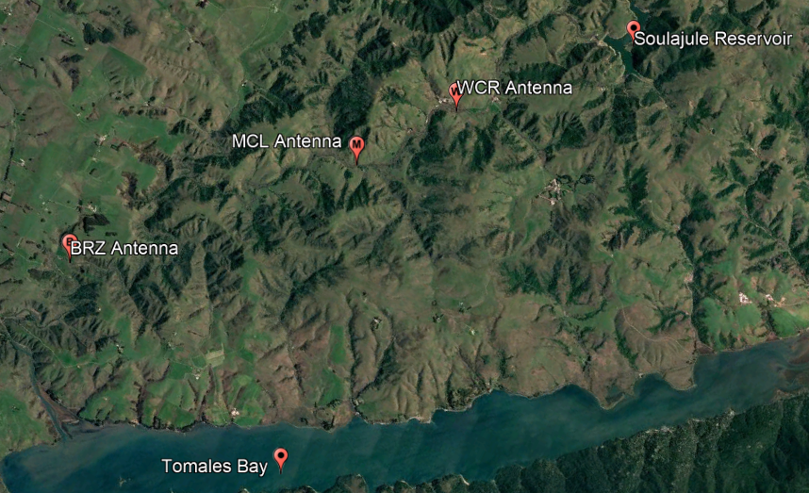

The Walker Creek Passive Integrative Transponder (PIT) Antenna Project has begun its second year of data collection. The primary goal of this project is to determine the migratory behaviors and spawning locations of hatchery-reared coho salmon in the Walker Creek Watershed, located in Marin County, CA. Partners for this project include CalTrout, UC Davis, the California Department of Fish and Wildlife (CDFW), California Sea Grant Russian River Salmon and Steelhead Monitoring Program (CA SeaGrant), US Army Corps of Engineers (USACE), as well as the landowners of the Walker Creek Ranch, McLaughlin Ranch, and Brazil Ranch. In the first year of data collection, which ran from December 2020 to June 2021, 260 adult coho were released by USACE and monitored using two PIT Antennas, both located on the Walker Creek Ranch property. For the 2021-22 field season, a few key program changes were enacted. First, the downstream antenna located at Jackrabbit Flat was moved to the McLaughlin Ranch Property (38.184183, -122.838664), where significant spawning activity was observed the previous year. Second, a third, new antenna was installed further downstream at the Brazil Ranch further downstream toward the mouth into Tomales Bay (38.225509, -122.892535), which will allow for better migration data to be collected and understand if out-of-basin fish enter or leave Walker Creek without migrating significantly upstream. The upstream antenna did not move from its location near Grinding Rock on the Walker Creek Ranch property (38.171541, -122.815607). The second major programmatic change was the release of tagged juvenile coho from the Warm Springs hatchery, located in Sonoma, CA. The second year of data collection will build upon the adult coho migration and spawning location information collected last year and will include data on juvenile habitat usage and migration in winter as well as smolt outmigration in the spring. This season, data downloads will be conducted by Alex Johanson for the Walker Creek Ranch (WCR) and McLaughlin Ranch (MCL) antennas, and the Brazil Ranch (BRZ) antenna data will be downloaded by Monica Tonty (CDFW).
The monitoring equipment for this project was generously supplied by the CA SeaGrant. The three antennas were installed on 11/18/21 by Will Boucher and Jason Held (CA Sea Grant), Patrick Samuel (CalTrout), and David Hines (CDFW). In total, 4,387 juveniles were released on 11/10/22, 1100 juveniles were tagged (25% of total releases) with Biomark APT 12mm FDX tags and were released at the WCR Antenna at Grinding Rock by Benjamin White and USACE Team. In total, 590 tagged adults were released in two locations over the course of three days. 357 adults were released at Grinding Rock on 12/28/21 (186 F, 170 M, 1 UNK), and 233 adults were released at Salmon Creek on 12/30/21 (122 F, 110 M, 1 UNK) (Table. 1). Data downloads for the antennas began on 11/26/21 and were originally planned to be conducted every two weeks but have since been reduced to weekly due to battery-related concerns. Spawner surveys have been conducted on three separate occasions but due to recent rains and an influx of sediment into the creek, in-stream conditions have limited visibility and as of 01/07/21 have resulted in no detections of adult salmonids or evidence of spawning.
In November and December, a total of 545 tags were detected on all three antennas, representing 474 individual fish (Table. 2). Of these 474 individuals, 57 were adults, all from the Walker Creek Release Group. This is interesting because it aligns with the results noted from the previous year that no fish from the upstream release site were ever detected on antennas. The first adult detected was a male coho from the Walker Creek release group and was detected on BRZ on 12/28/21. 34 individuals were detected multiple times, and 8 adults were shown moving from BRZ to MCL (moving US), one juvenile was shown moving from MCL to WCR (moving US), and one individual, that was not one of the individuals released for this project, was detected on all three antennas moving upstream. There were 2 juveniles shown moving downstream from MCL to BRZ, and 1 juvenile moving from WCR to BRZ, not detected on MCL (shown in Table. 3). 1 juvenile moved from WCR to MCL back to WCR, and 16 juveniles were shown twice on WCR, 5 juveniles were shown twice on MCL, and two adults were shown twice on BRZ (Table 4). Of the individuals detected moving US from BRZ to MCL, all were Adults from the Walker Creek Release Group. All individuals noted moving downstream were Juveniles from the Grinding Rock Release Group. No adults have been detected on the Walker Creek Antenna, due to battery failures that were identified on 01/07/22. Replacement batteries will be used starting on 01/15/22. 30 adults were detected on the BRZ antenna, and 36 adults were detected on the MCL antenna.
So far, there have been four individuals detected that were not part of either the Juveniles or Adults released for this project, and their tag IDs are:
- 3DD.003DEF05FC, detected on WCR on 11/26 - currently unknown
- 3DD.003BF2639A, detected on BRZ on 12/13 – currently unknown
- 3DD.003BF26238, detected on BRZ on 12/16 – adult released on 12/18/20, likely a dead tag
- 3DD.003D95CC59, detected on BRZ on 12/13, MCL on 12/14, twice on WCR on 12/15, and on WCR on 12/18, 12/19, and 12/20 – coho, Russian River mainstem smolt, released on 4/8/21 (likely a jack)
Spawner surveys will be paused until in-stream conditions allow for better visibility (Image 1). There is some concern that walking the creek in these conditions could prove detrimental to incubating eggs or hazardous to the surveyor, who works alone. Flows peaked at 1030 CFS on 12/15 and have remained around 50 CFS since (Image 2).
Table 1. Adult Salmon Release Data. Adults were released in two locations over the course of three days, at Grinding Rock on 12/28/21 and Salmon Creek on 12/30/21. Unfortunately, during this time, the WCR antenna was not functioning properly due to battery-related issues, and so far, no adults have been detected on the WCR Antenna.
 | Release Group
 | GR – 12/28/21 | SC – 12/30/21 | Total
M | 170 | 110 | 280
F | 186 | 122 | 308
UNK | 1 | 1 | 2
Total | 357 | 233 | 590

Figure 1. This graph represents total detections of juveniles by week from the middle of November to the end of December. Detections peaked in the first week, showing a majority of juveniles moving downstream from Grinding Rock where they were released (WCR Antenna) down to the McLaughlin Ranch property (MCL). The first juvenile detection on the downstream-most antenna (BRZ) did not occur until 12/13, and only 4 juveniles have been detected on BRZ, so it can be assumed that 99.6% of all tagged juveniles did not leave the system in December.

Table 2. Total Tags Detected in November and December by Date. Of the 545 detections, only 92 were identified as the same individual, meaning 453 tags recorded correspond to a singular individual.
Date | BRZ | MCL | WCR | Total Detected
11/19/2021 | 0 | 6 | 1 | 7
11/20/2021 | 0 | 244 | 66 | 310
11/21/2021 | 0 | 27 | 48 | 75
11/22/2021 | 0 | 1 | 12 | 13
11/23/2021 | 0 | 3 | 4 | 7
11/24/2021 | 0 | 3 | 5 | 8
11/25/2021 | 0 | 1 | 0 | 1
11/26/2021 | 0 | 0 | 8 | 8
11/27/2021 | 0 | 0 | 6 | 6
11/28/2021 | 0 | 0 | 2 | 2
11/30/2021 | 0 | 0 | 1 | 1
12/1/2021 | 0 | 0 | 1 | 1
12/3/2021 | 0 | 0 | 1 | 1
12/5/2021 | 0 | 0 | 1 | 1
12/11/2021 | 0 | 0 | 1 | 1
12/12/2021 | 0 | 0 | 1 | 1
12/13/2021 | 3 | 5 | 1 | 9
12/14/2021 | 1 | 1 | 0 | 2
12/15/2021 | 1 | 1 | 2 | 4
12/16/2021 | 1 | 0 | 0 | 1
12/17/2021 | 0 | 1 | 1 | 2
12/18/2021 | 0 | 0 | 3 | 3
12/19/2021 | 0 | 1 | 4 | 5
12/20/2021 | 0 | 0 | 1 | 1
12/21/2021 | 0 | 0 | 1 | 1
12/22/2021 | 0 | 0 | 1 | 1
12/25/2021 | 0 | 1 | 0 | 1
12/26/2021 | 0 | 1 | 0 | 1
12/27/2021 | 1 | 0 | 0 | 1
12/28/2021 | 4 | 0 | 0 | 4
12/29/2021 | 20 | 7 | 0 | 27
12/30/2021 | 7 | 21 | 0 | 28
12/31/2021 | 0 | 11 | 0 | 11
Total | 38 | 335 | 172 | 545

Table 3. Individuals shown moving in one direction, either upstream or downstream. 8 Adults were detected moving from the BRZ to MCL antennas, 1 juvenile was detected moving from the MCL to WCR antenna, and the individual that was seen moving upstream on all 3 antennas was identified as a smolt released into the Russian River in April of 2021 that is likely a Jack. 2 juveniles were identified moving downstream from the MCL to BRZ antennas, and one juvenile was seen first on the WCR and then on the BRZ antenna (not detected on MCL). And finally, one juvenile went from WCR, down to MCL, and back up to WCR.
Moving US
BRZ to MCL | # Detections | Life Stage | Release Group
3DD.003D792332 | 2 | A | WC
3DD.003D79233B | 2 | A | WC
3DD.003D79269E | 2 | A | WC
3DD.003D7926C0 | 2 | A | WC
3DD.003D7926CB | 2 | A | WC
3DD.003D7927CD | 2 | A | WC
3DD.003D7929A2 | 2 | A | WC
3DD.003DEF0847 | 2 | A | WC
MCL to WCR | # Detections | Life Stage | Release Group
3DD.003DEF0847 | 2 | J | GR
BRZ to MCL to WCR | # Detections | Life Stage | Release Group
3DD.003D95CC59 | 7 | UNK | Not Ours
Moving DS
MCL to BRZ | # Detections | Life Stage | Release Group
3DD.003DEEFAA8 | 2 | J | GR
3DD.003DEF069F | 2 | J | GR
WCR to BRZ | # Detections | Life Stage | Release Group
3DD.003DEF07CE | 3 | J | GR

Table 4. Individuals shown moving between antennas or holding on the same antenna.
Moving Between Antennas
WCR to MCL to WCR | # Detections | Life Stage | Release Group
3DD.003DEF06B1 | 3 | J | GR
Holding/Same Antenna
WCR | # Detections | Life Stage | Release Group
3DD.003DEEFA2B | 2 | J | GR
3DD.003DEEFA3E | 2 | J | GR
3DD.003DEEFA2B | 2 | J | GR
3DD.003DEEFA3E | 2 | J | GR
3DD.003DEF0567 | 2 | J | GR
3DD.003DEF0596 | 2 | J | GR
3DD.003DEF05D5 | 2 | J | GR
3DD.003DEF05D7 | 2 | J | GR
3DD.003DEF05F1 | 2 | J | GR
3DD.003DEF05FA | 13 | J | GR
3DD.003DEF0616 | 2 | J | GR
3DD.003DEF06A3 | 2 | J | GR
3DD.003DEF06C2 | 2 | J | GR
3DD.003DEF06E5 | 2 | J | GR
3DD.003DEF06EB | 2 | J | GR
3DD.003DEF0718 | 2 | J | GR
MCL | # Detections | Life Stage | Release Group
3DD.003DEEF9BC | 2 | J | GR
3DD.003DEEFA0C | 2 | J | GR
3DD.003DEF04F5 | 2 | J | GR
3DD.003DEF05A0 | 2 | J | GR
3DD.003DEF0710 | 2 | J | GR
BRZ | # Detections | Life Stage | Release Group
3DD.003D792722 | 2 | A | WC
3DD.003D7928F0 | 2 | A | WC

Image 1. This photo shows the current water quality conditions of Walker Creek as of 01/07/21. Spawner surveys were conducted on 3 separate occasions but due to the high turbidity of the water, they will be paused until conditions improve. There is concern that walking the creek without being able to see the gravel may result in disturbance to incubating eggs, so surveys will begin as soon as conditions allow.
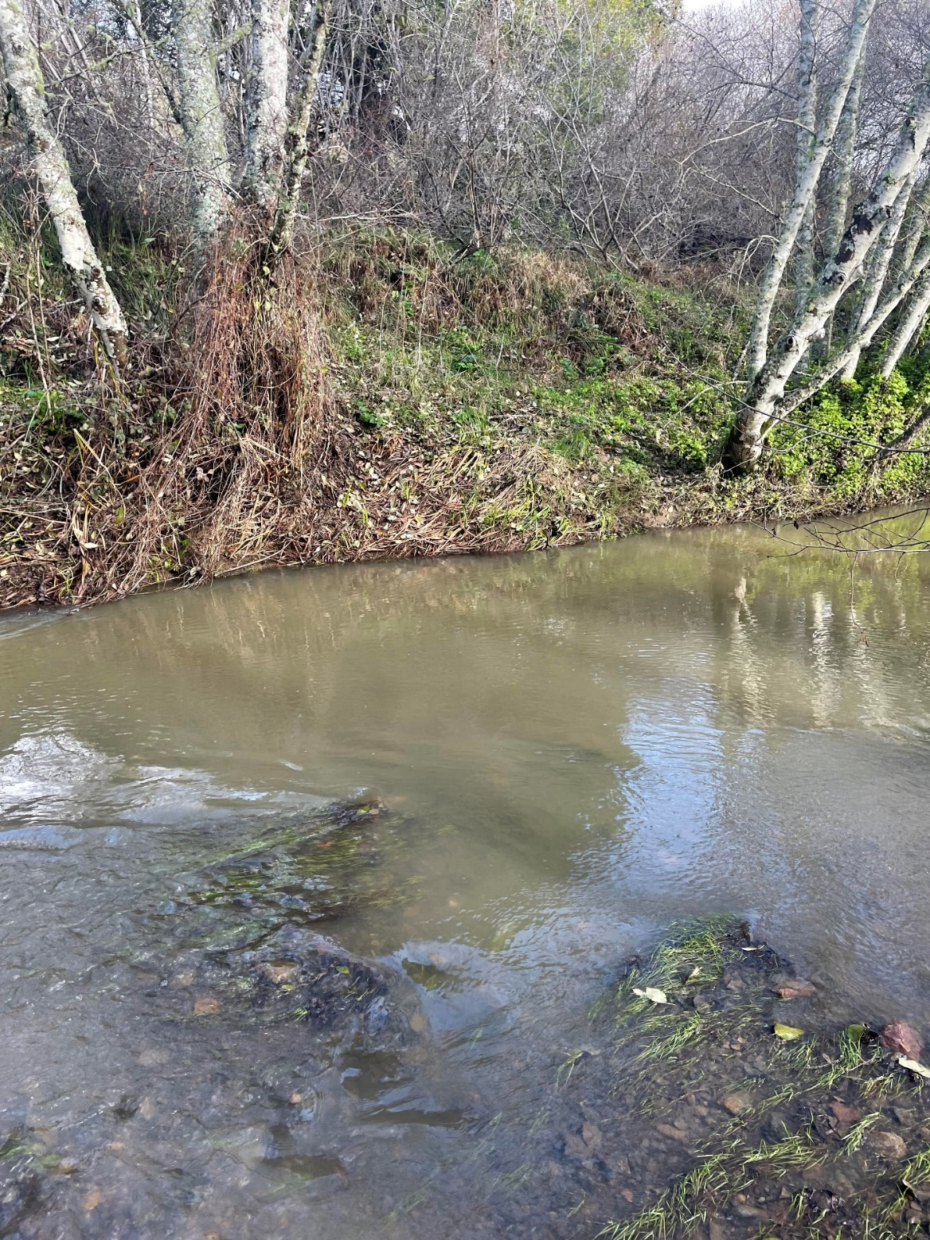

Image 2. This image shows flows registered in Walker Creek at the USGS Stream Gage in Marshall, CA, for the end of November and all of December. Flows peaked on 12/15 at 1030 CFS.
